

**MASTER’S IN DATA SCIENCE**

**2021-2022**

**Final Master’s Thesis**

**SPAIN’S MEDICINE ADMISSIONS APP**

**Author: Miguel Monedero Rubio**

# TABLE OF CONTENTS

# Page

# 1. INTRODUCTION 4

# 1.1 Context summary 5

# 1.2 Objective 6

# 1.2.1 Objective of this project 25

# 1.2.2 Objective of this document 25

# 1.3 Repository 7

# 2. DATA OBTENTION 19

# 2.1 Web page 7

# 3. DATA QUALITY 20

# 3.1 Data quality challenges 7

# 3.1.1 Column names containing scores 25

# 3.1.1 University names 25

# 3.1.1 Null values 25

# 3.1.1 Duplicated values 25

# 4. FEATURE ENGINEERING 20

# 4.1 Table schema 7

# 5. MODELLING 20

# 5.1 Correlation matrix 7

# 5.2 Linear Regression 7

# 5.2.1 Variables: [‘final_grade’] 25

# 5.2.2 Variables: [‘final_grade’, ‘year’] 25

# 5.2.3 Variables: [‘final_grade’, ‘year’, ‘covid_format_change’] 25

# 5.2.4 Variables: [‘final_grade’, ‘year’, ‘covid_format_change’, ‘diff_1_list’] 25

# 5.3 Linear Regression Per University 7

# 5.3.1 Variables: [‘final_grade’] 25

# 5.3.2 Variables: [‘final_grade’, ‘year’] 25

# 5.3.3 Variables: [‘final_grade’, ‘year’, ‘covid_format_change’] 25

# 5.3.4 Variables: [‘final_grade’, ‘year’, ‘covid_format_change’, ‘diff_1_list’] 25

# 5.4 ARIMA Per University 7

# 5.5 Metrics 7

# 5.6 Predict next year (2022) 1_list scores 7

# 6. FRONT-END 20

# 6.1 Objective 7

# 6.2 Filters and visualizations 7

# 6.2.1 Filters / Selectors 25

# 6.2.2 Bar chart with 1_list / final_grade scores by university 25

# 6.2.3 Map 25

# 6.2.4 Average scores by CCAA 25

# 6.2.5 Difference between 1_list and final_grade by university and CCAA 25

# 6.2.6 Historical scores and correlation heatmap 25

# 6.3 Video using front-end 7

# 7. CONCLUSION 20

# 1. INTRODUCTION

# 1.1 Context summary

Historically, Medicine has always been one of the most demanded careers to study in Spain. Nowadays, it’s still one of the hardest careers to get in, due to the high demand of people wanting to study this career in a public university (because of economic pricing, big different in comparison to a private university, plus reputational reasons) and the very few available slots.

To be able to study this career in Spain, you need to achieve a certain average score in “Selectividad”. “Selectividad” is the popular name given to the Spanish University Admission Tests ("Evaluación de Acceso a la Universidad", E.v.A.U.), a non-compulsory exam taken by students after secondary school, necessary to get into university. Students must take six 90-minute written exams over three days in June/July, consisting of common and specific subjects taken in "Bachillerato" (the last two non-compulsory years of secondary education). “Selectividad” exams are set by the Public Universities of each [autonomous community](https://en.wikipedia.org/wiki/Autonomous_communities_of_Spain) and allow students access to the Spanish university system.

Once you do “Selectividad” the universities publish the score you need in order to enter their university, this score is a number ranging from 0 to 14. They publish these scores in the web pages corresponding to each university, meaning that applicants need to consult these scores in each of the university web pages, making it hard to have a holistic view. There are a few web pages that consolidate this information and put it in one single place to have centralized platform. However, these web pages just so a table containing the scores from the different universities and do not show any visualizations or filters in order to facilitate users consult this information.

# 1.2 Objective

# 1.2.1 Objective of this project

There are two objectives for this project:

1. Predict next year scores
2. Create a centralized and accessible place, in this case it will be a web app, to consult the different Medicine admission grades from all the universities in Spain, in a visual and helpful manner. This app will help people save time by not having to go to each of the universities web pages to consult the different scores. Also, it will help guide the user in order to help them make the decision that works best for them.

# 1.2.2 Objective of this document

The objective of this document is to explain the end-to-end process of creating this project, going into detail on the challenges found and the decisions made along the way.

# 1.3 Repository

Take from readme

# 2. DATA OBTENTION

In this section we will be describing the source from which we got the data to do this project.

# 2.1 Web page

The source of data is coming from a web page called “**ACCESO A LAS FACULTADES DE MEDICINA DE ESPAÑA Y NOTAS DE CORTE”** that you can find in the following link:

* <https://sites.google.com/site/notasdecorte/>

The data we are using is found on the left side of the web page *(“Notas de corte de medicina year/year+1”)*, see figure 1:

**Figure 1: Web page from which data was taken**

There is data going from the period of year 2010-2011 till 2021-2022, this is, a total of 12 years:

1. 2010/2011
2. 2011/2012
3. 2012/2013
4. 2013/2014
5. 2014/2015
6. 2015/2016
7. 2016/2017
8. 2017/2018
9. 2018/2019
10. 2019/2020
11. 2020/2021
12. 2021/2022

Each year has its own excel file. Example of data that can be found in year 2010-2011 can be seen in figure 2:

**Figure 2: Medicine admission scores for year 2010-2011**

The columns shown above are the following:

1. **“Notas de corte de Medicina”:** names of the different public universities
2. **“Última fecha admisión (Fecha de la nota final)”:** date in which the last list (final grade) is published
3. **“Nota de corte final de Medicina”:** last list published (final grade), this is, the last score published meaning it’s the lowest score in order to be admitted to that university
4. **“1ª Lista”:** first list published, therefore the highest score. This score is ranging between 0-14.
5. **“Sobre 10”:** here they are showcasing the score corresponding to an Nª List but in range 0-10 instead of 0-14. Since this is rarely used, for the purpose of the project we will be analyzing the scores ranging between 0-14.

# 3. DATA QUALITY

In this section we will be describing the different data quality challenges we faced creating this project and how we solved them.

# 3.1 Data quality challenges

Since the data source is coming from 12 different excel files, we need to take into account the following:

* **Column names containing scores:** make sure the columns containing the scores are consistent, and in case they are not, create a standardized column name. Also, make sure they are all a certain type of data, in this case, float.
* **University names**: make sure they are consistent throughout the different years, and in case they are not, create a standardized name.
* **Null values**: records that have null values across all the columns should be deleted.
* **Duplicated values:** make sure we do not have any duplicated values.

# 3.1.1 Column names containing scores

We have created 2 new columns called “1_list” and “final_grade” to have a standard name since in there were consistency issues between the different data sources. Example:

The column “final_grade” has different names depending on the year. A few different names found that refer to the same data are:

* “Nota de corte final de Medicina”
* “Nota de corte final”
* “Nota de corte actual”

# 3.1.2 University names

We have taken the names of the last year (2021) as reference, and we realized 2 things:

1. **There are 13 universities which have a different name than the ones in 2021 data and need to be mapped**

To solve this, we have used the function SequenceMatcher:

* + from difflib import SequenceMatcher

This function gives a ratio of similarity between two strings, this way we can accelerate the process of finding the corresponding university name in 2021.

On figure 3, you can see on the left-hand side, the 13 universities that have a different name than on the right-hand side (list of university names from 2021, that we are using as a reference). As you can see, it’s not 100% accurate but it is still helpful to map most of the names in a quick manner.

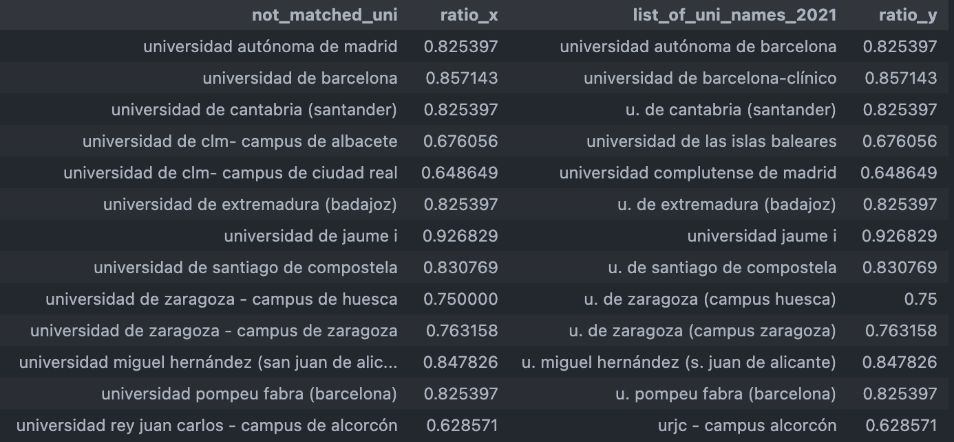

**Figure 3: SequenceMatcher ratios**

1. **There are different number of universities per year**

As you can see on figure 4, there are different number of universities per year. This is due to the fact that some universities have started teaching Medicine and have added this degree in their university.

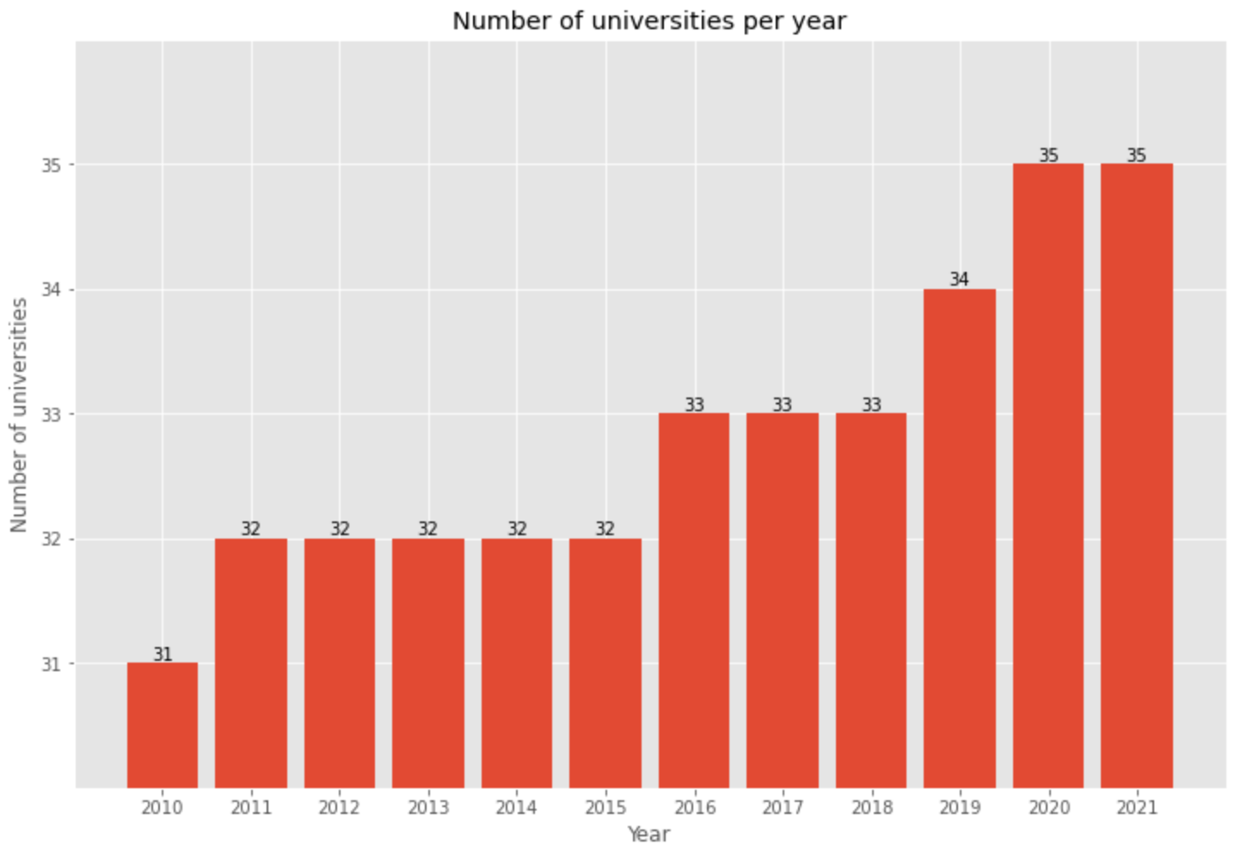

**Figure 4: Number of universities per year**

Analyzing the data, the names of the universities that have started teaching Medicine in the years above are:

* + 2011: universidad jaume i
  + 2016: universidad de las islas baleares
  + 2019: universidad pública de navarra
  + 2020: universidad de barcelona-bellvitge

# 3.1.3 Null values

We have done a quality check to make sure there aren’t any nulls. Please see code on figure 5: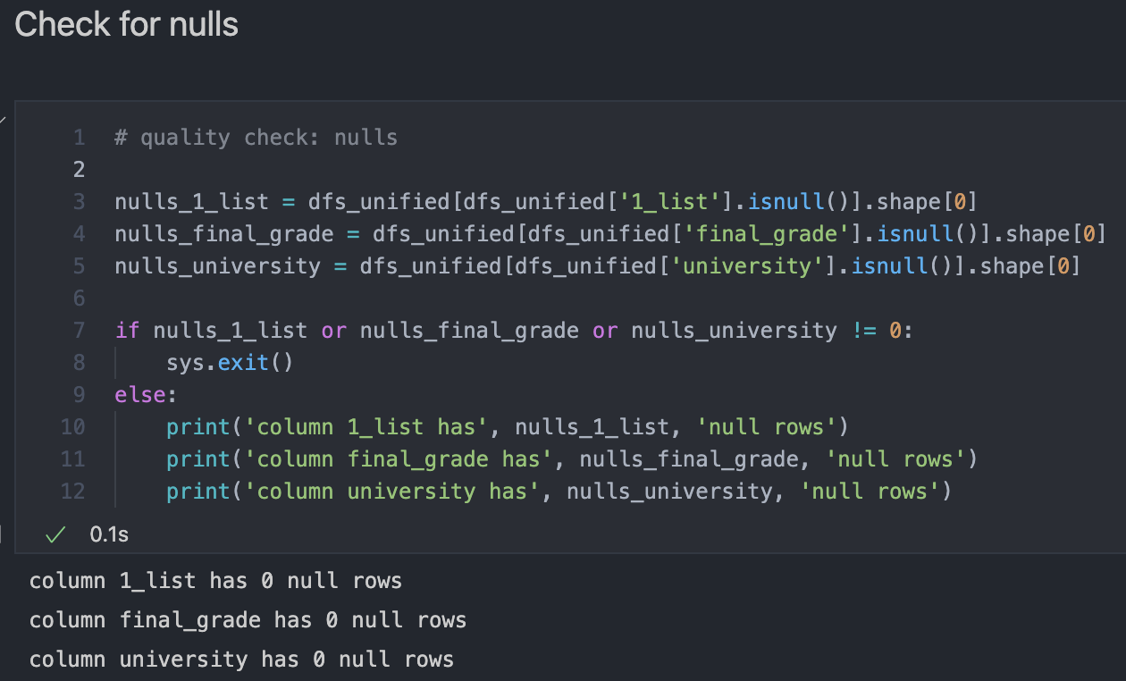

**Figure 5: Nulls quality check**

# 3.1.4 Duplicated values

We have also done a quality check to make sure there aren’t any duplicated values. Please see code on figure 6:

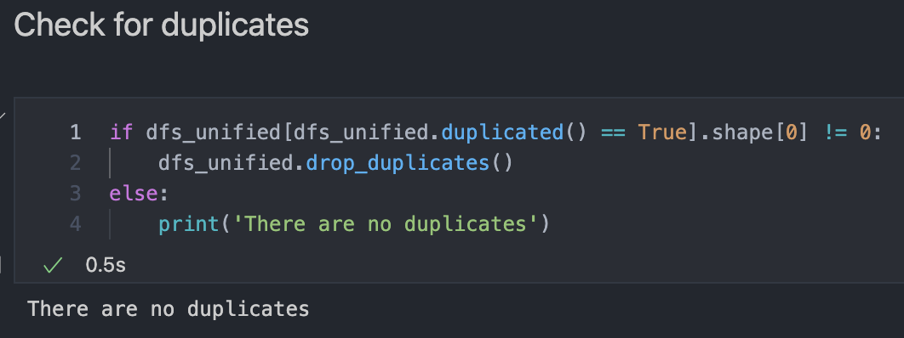

**Figure 6: Duplicates quality check**

# 4. FEATURE ENGINEERING

In this section we will be describing the different features that have been added in order to be considered in the correlation matrix described in section 5 (Modelling). Also, we will be defining the columns that we had already created before this section. The way we are going to do these 2 tasks is by creating a table schema of all the columns.

# 4.1 Table schema

Columns we previously had before this section:

* **year:** Indicates the year from which the data is. Values range from 2010 to 2021. In section 5 (Modelling) we will be predicting the scores for 2022 and will be adding them to the existing table, therefore values will range from 2010 to 2022
* **university:** String containing the university name
* **1_list:** Float containing the first score published. This is the highest score to be admitted at a university
* **final_grade:** Float containing the last score published. This is the lowest score to be admitted at a university
* **since_2010:** Indicates whether the university has been teaching the medicine career since 2010 or not. In case it does, value of this column is “True”. If not, the value will be the year from which that university has been teaching the career

Columns added:

* **city:** String that contains the city in Spain where the university is
* **CCAA:** String that contains the Spanish community corresponding to the university
* **diff_1_list:** Float that is the difference of the 1_list column between the current year and the previous year. For year 2010, this column’s value is NaN since we don’t have data from the previous year (2009)
* **diff_final_grade:** Float that is the difference of the final_grade column between the current year and the previous year. For year 2010, this column’s value is NaN since we don’t have data from the previous year (2009)
* **diff_1_list_final_grade:** Float that is the difference between the 1_list and final_grade columns for the current year
* **latitude:** Float containing the latitude corresponding to the location of the university. Values have been extracted from this web page: <https://www.mapcoordinates.net/es>
* **longitude:** Float containing the longitude corresponding to the location of the university. Values have been extracted from this web page: <https://www.mapcoordinates.net/es>
* **covid_format_change:** Due to COVID-19 the format of the tests from “Selectividad” changed, since they considered students weren’t as prepared as usual and had to make a change in the way the tests were done, to make it easier for the students. Before COVID-19, the exams had two options, option A or option B, you had to do all the questions that were on the option that you chose. In 2020, they changed this by letting the student choose the questions that they want to do, doesn’t matter if they are in option A or B. You can notice this difference in the “1_list” scores that went up an average of 0.408 in 2020 in comparison to 2019, when before 2020 this average score was of 0.07. Please see figure 7:

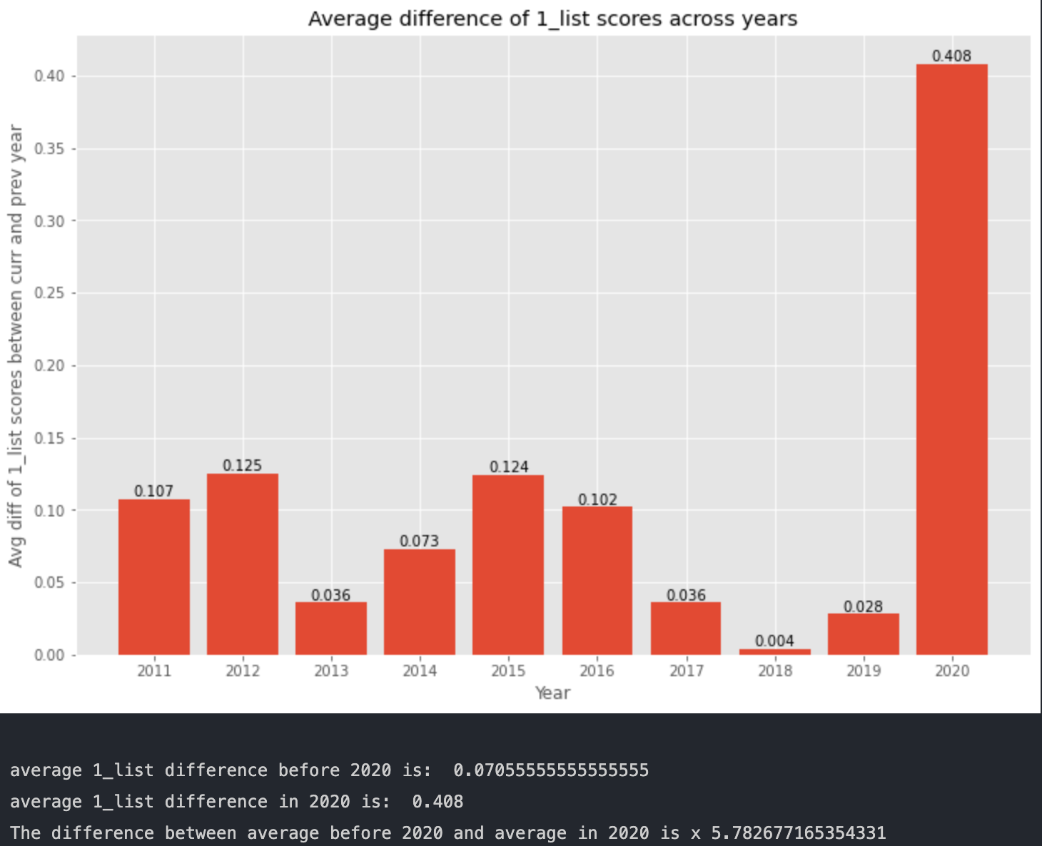

**Figure 7: Average difference of 1_list scores before 2020 and in 2020**

Therefore, it’s relevant to create a variable that reflects this change. This field has two different values, 1 if the year is >= 2020 and 0 if it’s < 2020

# 5. MODELLING

In this section we will be predicting the 1_list scores for 2022. In order to do so, we will need to analyze which models and variables to use. As the output variable “1_list” is a number we need to solve a regression problem. Therefore, models that we will be analyzing are Linear Regression and ARIMA.

# 5.1 Correlation matrix

To analyze the linear correlation between variables, we have created a correlation matrix. Please see figure X:

**Figure 7: Correlation matrix**

As we can see in the figure above, highlighting the output variable “1_list” we can see that the variables with higher linear correlation are:

* **year**: 0.79
* **final_grade**: 0.92
* **covid_format_change**: 0.66
* **diff_1_list**: 0.34

We will be using these variables in the models below to analyze which combination has the lowest error.

# 5.2 Linear Regression

In this section we will be using the data before 2021 as training data and the year 2021 as test data. The reasoning behind this choice is that as we have explained before, the scores incremented considerably do to the change in the test format (due to COVID-19) in 2020. This way we could train the model considering this year and predict more efficiently the scores for 2021 (tests this year also had the format applied due to COVID-19).

In the next sections we will be showcasing the results obtained by using different variables in the model.

# 5.2.1 Variables: [‘final_grade’]

First model training was done with the variable “final_grade”, which was the one that we saw above that had the highest correlation (0.92), with the target variable. Please see in figure 8 the results obtained:

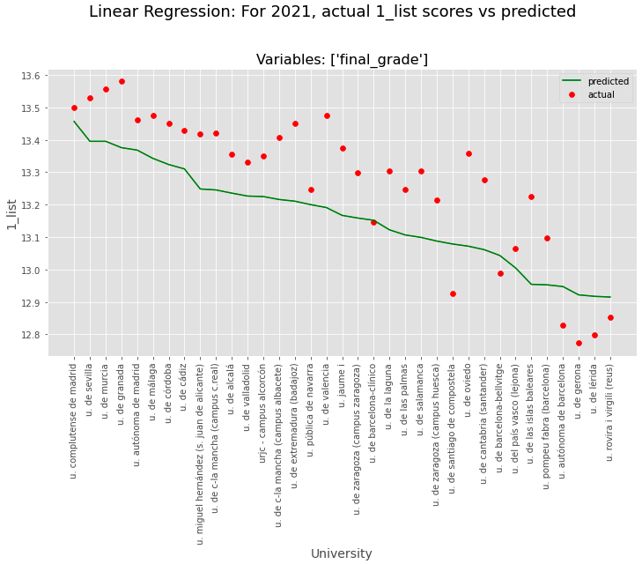

**Figure 8: Linear Regression – variables: final_grade**

Analyzing the graph above, we can see that as a base model, the model has predicted a similar trend than the actual data, although a bit lower scores than expected.

# 5.2.2 Variables: [‘final_grade’, ‘year’]

Second model training was done with the variables “final_grade” and “year”, which were the two variables with highest correlation (0.92 and 0.79, respectively). Please see in figure 9 the results obtained:

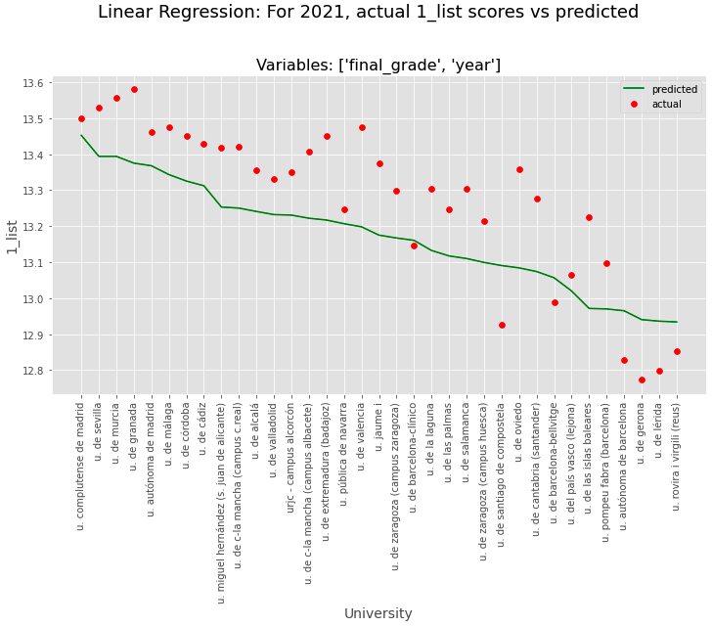

**Figure 9: Linear Regression – variables: final_grade, year**

Analyzing the graph above, we can see that the prediction is very similar to the previous one where we used only the variable “final_grade”. There is still room for improvement.

# 5.2.3 Variables: [‘final_grade’, ‘year’, ‘covid_format_change’]

Third model training was done with the variables “final_grade”, “year” and “covid_format_change”, with the following correlations: 0.92, 0.79 and 0.66, respectively. Please see in figure 10 the results obtained:

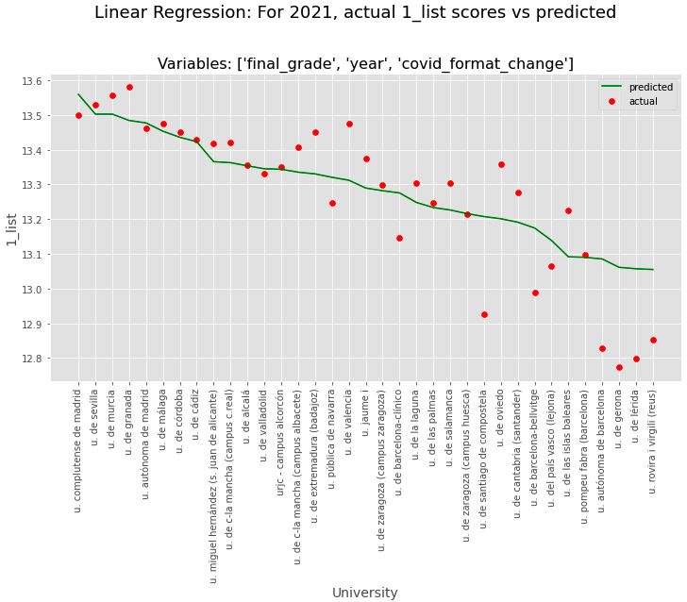

**Figure 10: Linear Regression – variables: final_grade, year, covid_format_change**

Analyzing the graph above, there is a significant difference between this prediction and the 2 previous ones. In general terms, it seems as there is less error. We will analyze this in detail in the section where we calculate the metrics (MAE, MSE, RMSE) obtained.

# 5.2.4 Variables: [‘final_grade’, ‘year’, ‘covid_format_change’, ‘diff_1_list’]

The fourth and last model training (for Linear Regression) was done with the variables “final_grade”, “year”, “covid_format_change” and “diff_1_list”, with the following correlations: 0.92, 0.79, 0.66 and 0.34, respectively. Please see in figure 11 the results obtained:

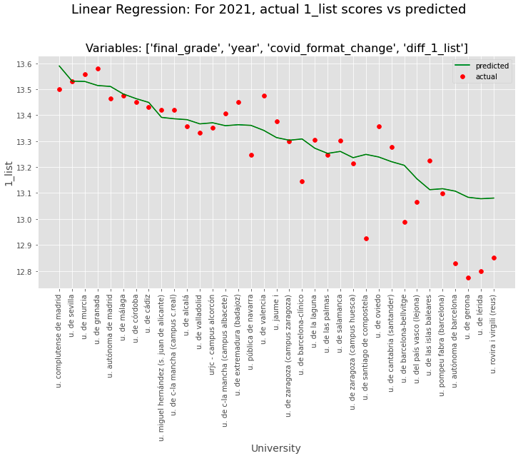

**Figure 11: Linear Regression – variables: final_grade, year, covid_format_change, diff_1_list**

Results seem to be similar to the ones obtained with the 3 variables: final_grade, year, covid_format_change. Error might be slightly higher due to the fact that this time we have trained the model with a variable with a not very high linear correlation (diff_1_list: 0.34). We will analyze this in detail in the metrics section.

# 5.3 Linear Regression Per University

In this section we will be doing the same methodology we did before, using the data before 2021 as training data and the year 2021 as test data, but doing this per university. Therefore, we will be creating 35 different models.

In the next sections we will be showcasing the results obtained by using different variables in the model.

# 5.3.1 Variables: [‘final_grade’]

First iteration training the 35 models was done with the variable “final_grade”. Please see in figure 12 the results obtained:

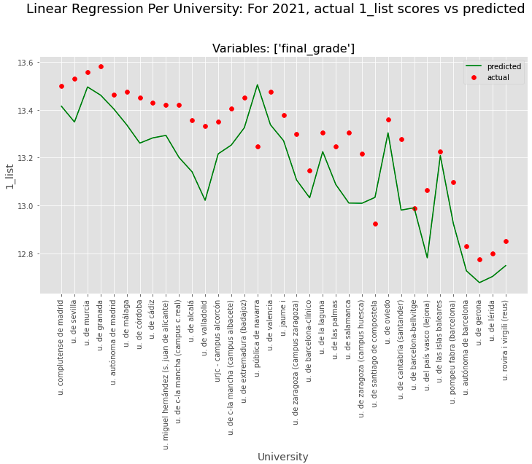

**Figure 12: Linear Regression Per University – variables: final_grade**

Analyzing the graph above, we see that the prediction is not almost a “straight” line as we were seeing before, but rather a more targeted prediction because in this case we are doing one model per university. Overall, the predictions seem a bit lower than the actual score, there is still room for improvement.

# 5.3.2 Variables: [‘final_grade’, ‘year’]

Second iteration training the 35 models was done with the variables “final_grade” and “year”. Please see in figure 13 the results obtained:

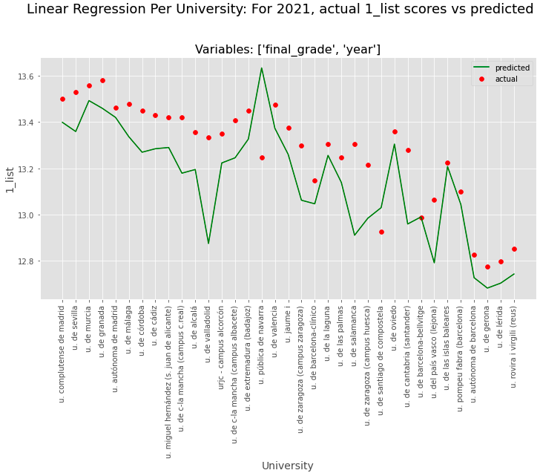

**Figure 13: Linear Regression Per University – variables: final_grade, year**

Similar trend as the previous scenario seen with only the variable “final_grade”. In general terms, predicted scores seem lower than actual ones.

# 5.3.3 Variables: [‘final_grade’, ‘year’, ‘covid_format_change’]

Third iteration training the 35 models was done with the variables “final_grade”, “year” and “covid_format_change”. Please see in figure 14 the results obtained:

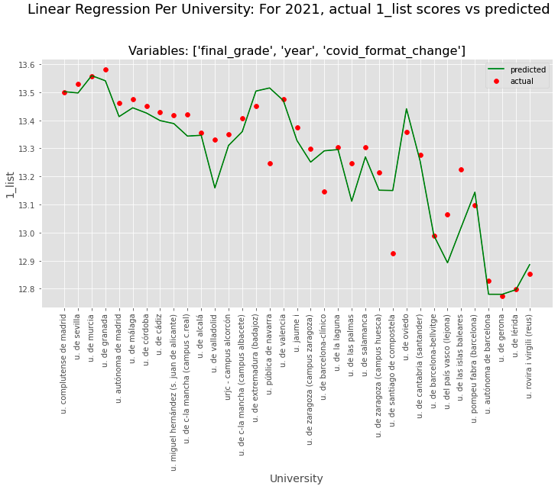

**Figure 14: Linear Regression Per University – variables: final_grade, year, covid_format_change**

Analyzing the graph above, we can see that the predicted scores are noticeably more accurate than the first two iterations. The predicted scores don’t seem as low as in the other iterations in comparison to the actual ones.

In the metrics section we will most likely see this combination (Linear Regression per university models using variables final_grade, year and covid_format_change) as one of the ones, or the one, with less error.

# 5.3.4 Variables: [‘final_grade’, ‘year’, ‘covid_format_change’, ‘diff_1_list’

Fourth and last iteration training the 35 models was done with the variables “final_grade”, “year”, “covid_format_change” and “diff_1_list”. Please see in figure 15 the results obtained:

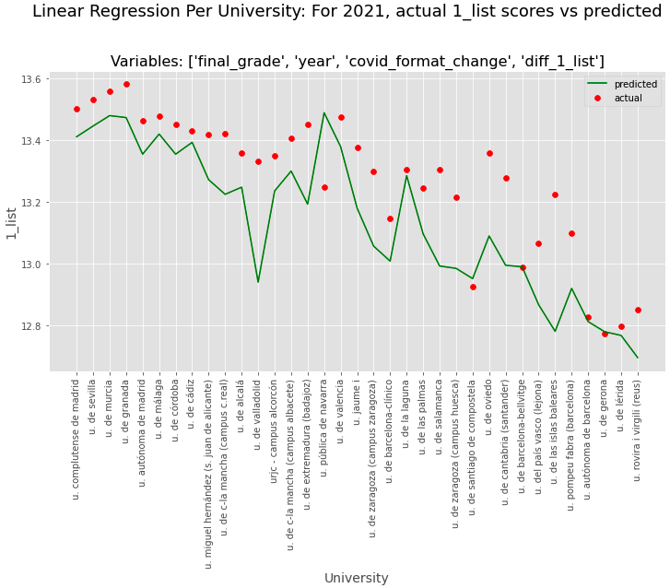

**Figure 15: Linear Regression Per University – variables: final_grade, year, covid_format_change, diff_1_list**

Since in this case we are introducing a variable with low linear correlation (diff_1_list: 0.34) we could have expected that the model prediction would be worse than without this variable and indeed, looking at the graph above we see that the predicted scores are not as accurate and are overall quite below the actual scores.

# 5.4 ARIMA Per University

In this section we will be doing the ARIMA model instead of Linear Regression. Same methodology as before, using the data before 2021 as training data and the year 2021 as test data, and doing this per university. Therefore, we will be creating 35 different models. Please see in figure 16 the results obtained:

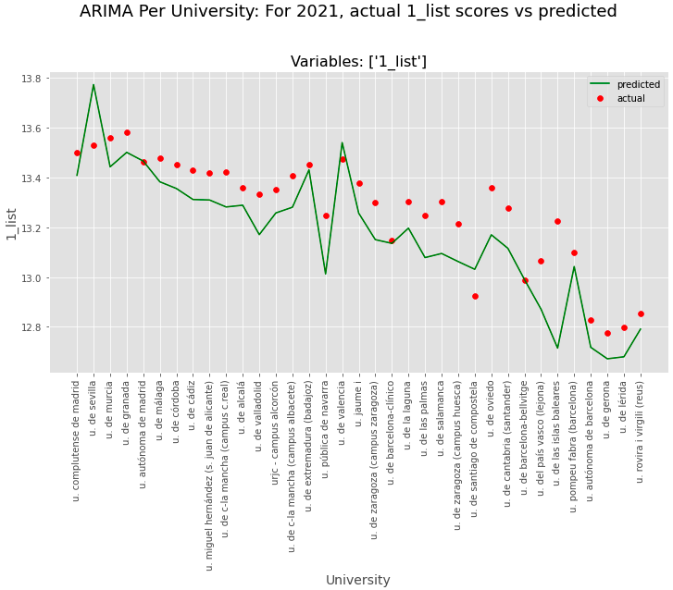

**Figure 16: ARIMA per university – variables: 1_list**

We have used the variable 1_list in the 35 ARIMA models and we can see that the predicted scores are quite below the actual ones.

# 5.5 Metrics

The metrics we are going to use to evaluate the different models showcased are MSE (Mean Squared Error), RMSE (Root Mean Squared Error) and MAE (Mean Absolute Error). In figure 17, we can see the scores of these metrics for the different combination of models and variables analyzed in previous sections:

**Figure 17: Comparison of Model Metrics**

Analyzing the graph above we can see that the model-variables combination with less MSE, RMSE and MAE is the Linear Regression Per University using the variables “final_grade”, “year” and “covid_format_change”. Therefore, we will be using this combination to predict the 2022 “1_list” scores.

# 5.6 Predict next year (2022) 1_list scores

As discussed in the previous section, we will be doing a Linear Regression Per University, training the models with the variables “final_grade”, “year” and “covid_format_change”, since with this combination we observed it had the least MSE, RMSE and MAE out of all the other combinations analyzed.

To predict the next year (2022) **“1_list”** scores we input as variables the following data:

* **“final_grade”:** “final_grade” of previous year (2021)
* **“year”:** 2022
* **“covid_format_change”:** 1.0, as they will still be using the same test format used since COVID-19 in 2020.

To get the next year (2022) **“final_grade”** scores we calculated them the following way: for every university, we took the predicted “1_list” score (2022) and subtracted the difference between the “1_list” and “final_grade” that the university had the previous year (2021). The formula would like this:

**“final_grade” (2022) = “1_list” (2022) – diff_1_list_final_grade (2021)**

# 6. FRONT-END

In this section we will discussing how the front-end was done and analysis of the different data visualizations that are in it.

The front-end has been done on streamlit, to use it you will need to run the following the “myapp.py” file.

# 6.1 Objective

The objectives of the front-end are to make a **simple and interactive interface**, so that a user could understand and start using right away, and making it **insightful** by showcasing not only the grades from the different universities but also providing additional information such as location of the universities, historical scores, filters to see if you could be admitted given a certain score, etc.

# 6.2 Filters and visualizations

There are many graphs and functionalities created to fulfill the objectives mentioned above.

# 6.2.1 Filters / Selectors

In figure X you can see highlighted the filters/selectors section. There are 4 different options:

* **“Select year”**: to showcase data from the year selected. Values range from 2010 to 2022.
* **“Select score”**: to choose between showcasing the “1_list” scores or the “final_grade” ones.
* **“Filter by CCAA (optional)”**: you can filter by the autonomous communities of Spain, in case you are interested in a particular one. This filter is optional, in case you don’t select a specific community the default value is “All” which will show data from all of them.
* **“Filter by score (optional)(e.g., 12.5)”**: you can filter by a score. This is very helpful if you already know your score, or can sense the score you will get, and want to see the different universities you could be admitted to. This filter is optional.

**Figure X: Top part of front-end with focus on filters / selectors**

**Figure 18: Filters**

# 6.2.2 Bar chart with 1_list / final_grade scores by university

**Figure 19: Bar chart of scores per university**

# 6.2.3 Map

Hover over functionality

And click

Click and drag to move through the map

Filter by a score – color changes

**Figure 20: Map with locations of universities**

# 6.2.4 Average scores by CCAA

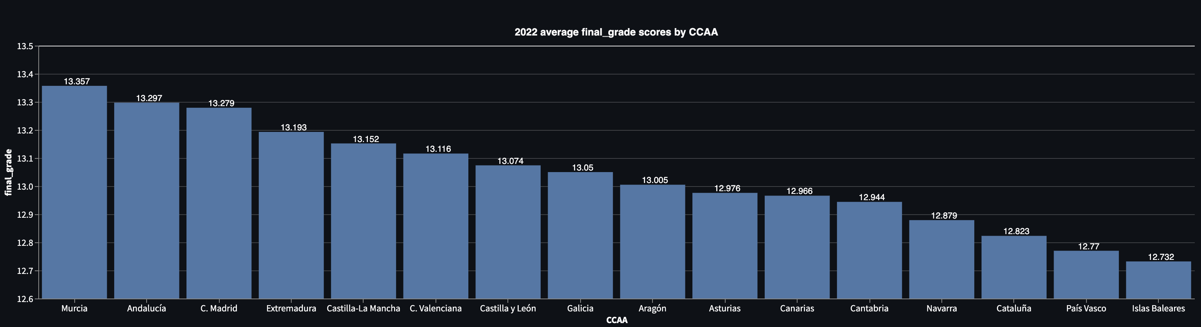

**Figure 21: average scores by CCAA**

# 6.2.5 Difference between 1_list and final_grade by university and by CCAA

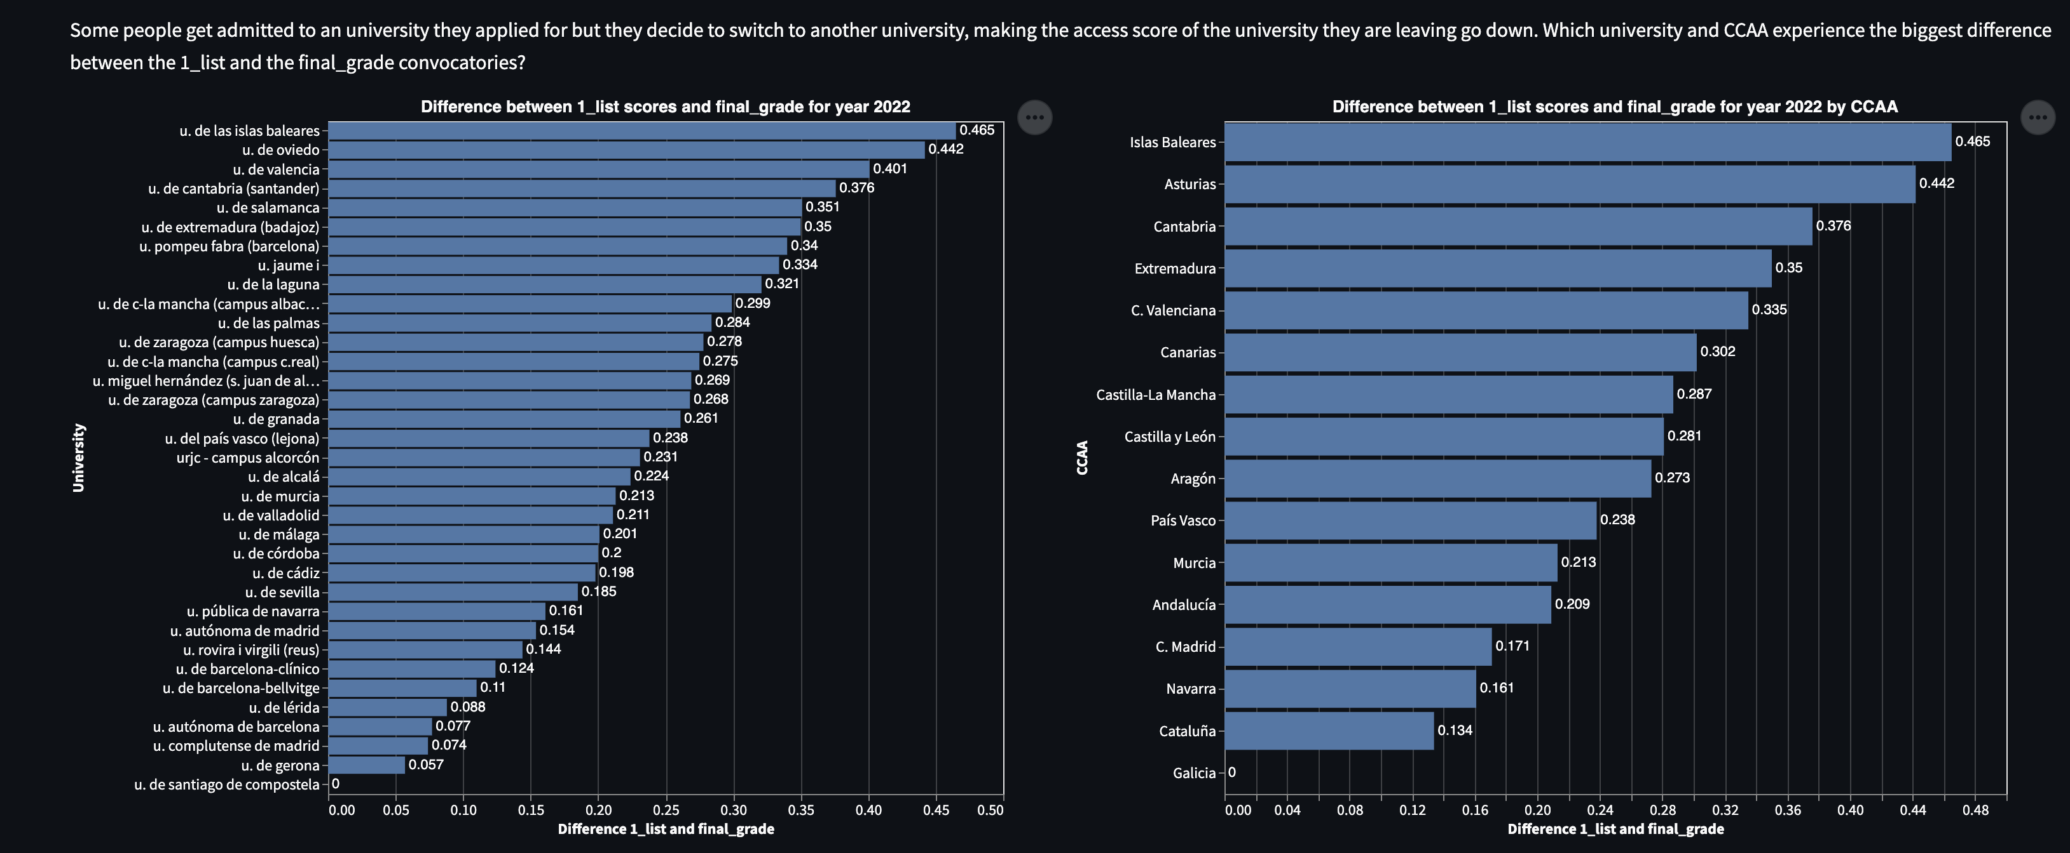

**Figure 22: Difference between “1_list” and “final_grade” by university and by CCAA**

# 6.2.6 Historical scores and correlation heatmap

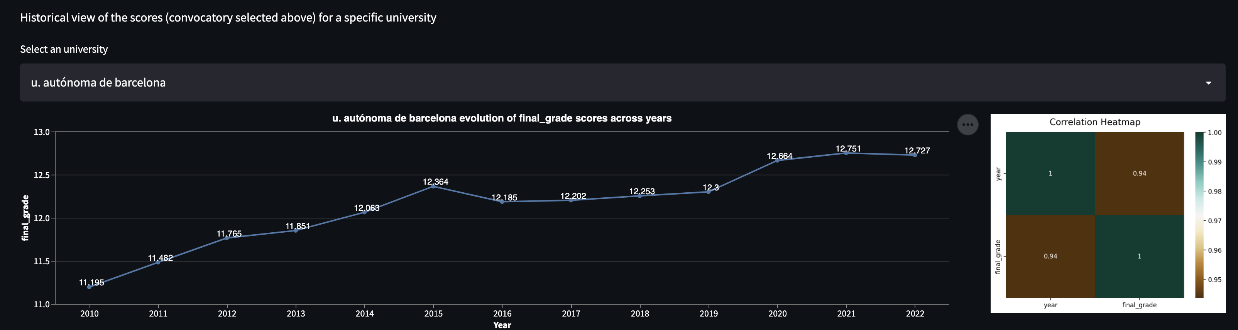

**Figure 23: Historical scores and correlation heatmap for university selected**

# 6.3 Video using front-end

In the following video you can get a feeling of the different functionalities and visualizations that have been mentioned above:

Figure X: video

# 7. CONCLUSION